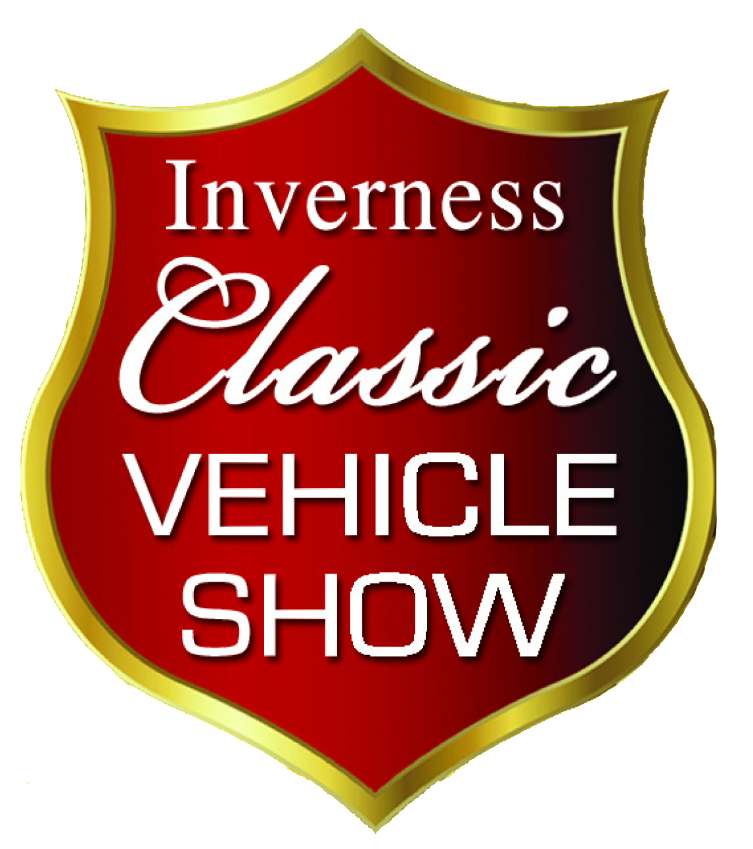
Inverness Classic Vehicle Show
Saturday 14TH May 2016
Vehicle Entry Form
CLOSING DATE – MONDAY 25TH APRIL 2016

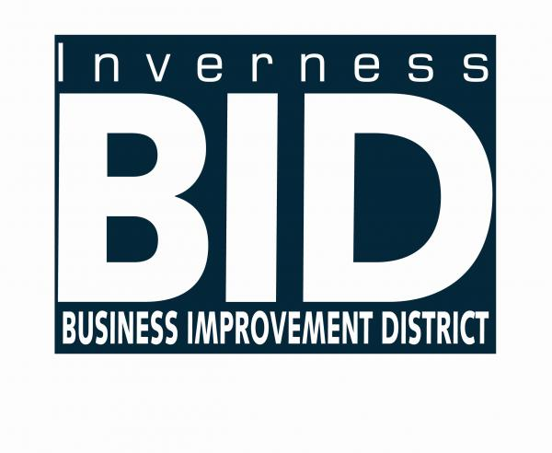
ENTRANT INFORMATION:

Name
Address
Postcode |  | Email
Home Phone |  | Mobile
VEHICLE INFORMATION:

Type of Vehicle Please x appropriate box |  |  | Car |  | Truck or Bus |  |  | Motorcycle |  |  | Pedal Cycle
Make |  |  |  |  | Model
Year of Manufacture |  |  |  |  | Registration Number

OTHER INFORMATION:

Have you previously entered the Inverness Classic Vehicle Show? YES |  |  |  |  |  |  |  |  |  |  |  |  | NO
Are you a member of a Car Club? YES |  |  |  |  |  | NO |  |  | Car Clubs will be located together where possible
If YES name of Car Club
Do you have a preference on your vehicle location? Please tick box below (NOTE: This is NOT guaranteed and later entries will be allocated where space is available)
Church Street |  | High St /Inglis Street |  |  |  |  | Falcon Square |  |  |  | *Castle |  |  |  | No preference
*Unfortunately due to traffic restrictions it will not be possible for vehicles located at the Castle to take part in the Parade Finale. It is proposed that all Tractors & Buses will be located at the Castle.

CONDITIONS OF ENTRY:
- The event is fully covered by Public Liability Insurance, however valid insurance cover must be held by all entrants for their vehicles as neither the organisers nor the vehicle owners will be held responsible for any vehicle damage
- All vehicles driven onto event must have valid road tax, insurance and MOT (where relevant)
- A speed limit of 5mph applies on the site at all times and all vehicle movement will be controlled by the Event Stewards
- Vehicles must be securely braked
- Vehicles must be clean, complete and in safe working order
- All leakages must be kept to an absolute minimum considering the age of the vehicle
- The driver must hold the appropriate license to drive their vehicle
- Vehicles are entered at owner’s own risk
- By signing this form you have read and abide by all the above conditions of entry.
- Only signed entries can be accepted.

SIGNED:…………………………………………………………………..………. DATE: / /2016

Inverness BID Ltd, 111 Academy Street, Inverness, IV1 1LX
Tel: 01463 714550. Fax: 01463 715060 Email: margaret@inverness.uk.com

